|  |  |
| --- | --- |
| **ADVANCED SYSTEMS LABORATORY**  **P.O. KANCHANBAGH**  **HYDERABAD - 500 058** | **Doc. No. : DSL-LEVEL II SIMULATOR-HDD-01**  **Issue No. : 0.0**  **Issue Date :**  **No. of Pages : 98** |
|  | |
| **TITLE**  **Hardware Design Document (HDD) for**  **LEVEL II SIMULATOR** | |
| |  |  |  |  |  | | --- | --- | --- | --- | --- | | **PREPARED BY :** | | | | | | **Mr. Srinivas K**  **M/S DATASOL (B) Pvt Ltd** | |  | **Mr Anand R**  **M/S DATASOL (B) Pvt Ltd** | | | **REVIEWED BY :** | | | | | | **Mr KAREEM REDDY Sc “C”**  **Ms LAVANYA Sc “D”**  **M/S ADVANCED SYSTEM LABORATORY** | **Mr GIRIDHAR RAO**  **R & QA**  **M/S ADVANCED SYSTEM LABORATORY** | | | **Mr SATHYANARAYANA**  **SSQAG-REP** | | **APPROVED BY:** | | | | | | **Ms R SHEENA RANI Sc “G”**  **Technology Director, SINT CHECKOUT**  **M/S ADVANCED SYSTEM LABORATORY** | | | | | | |
| **Manufactured By:**  **DATASOL (B) PVT.LTD.**  “Datasol House”, #793, 17th Cross,  Vyalikaval HBCS, (Behind BEL Corporate Office),  Veeranna Pallya, Nagawara BANGALORE - 560045 | |

**Record of Revisions**

|  |  |  |  |  |  |
| --- | --- | --- | --- | --- | --- |
| Sl. No. | Issue No. | Date | Section (s) changed | Changed  By  (Datasol | Details of Revisions |
| 1. | 0.0 |  | -- |  | -- |
|  |  |  |  |  |  |
|  |  |  |  |  |  |
|  |  |  |  |  |  |
|  |  |  |  |  |  |
|  |  |  |  |  |  |
|  |  |  |  |  |  |
|  |  |  |  |  |  |
|  |  |  |  |  |  |
|  |  |  |  |  |  |
|  |  |  |  |  |  |
|  |  |  |  |  |  |
|  |  |  |  |  |  |
|  |  |  |  |  |  |

**Document Copy No:**

|  |  |  |
| --- | --- | --- |
| **Copy No.** | **Distributed To** |  |
| 01 | RCI |  |
| 02 | SSQL |  |
| 03 | End User (ASL) |  |
| 04 | Datasol (B) Pvt. Ltd. |  |

standard definations :

* SIB - SIMULATOR INTERFACE BOX
* SIU - SIMULATOR INTERFACE UNIT
* MIU - MISILE INTERFACE UNIT
* SIMPC - SIMULATOR PC
* SBC - SINGLE BOARD COMPUTER
* KVM - KEYBOARD, VIDEO, MOUSE
* LJB - LAUNCHER JUNCTION BOX
* LIU - LAUNCHER INTERFACE UNIT
* SSD - SOLID STATE DRIVE
* RAM - RANDOM ACCESS MEMORY
* CPU - CENTRAL PROCESSING UNIT
* DVD - DIGITAL VIDEO DISK
* I/O - INPUT / OUTPUT

|  |  |
| --- | --- |
| **TABLE OF CONTENTS** |  |
| 1 SCOPE | 5 |
| 1.0 SIMULATOR RACK | 5 |
| 1.1 SPECIFICATIONS OF SIMULATOR RACK | 5 |
| 1.2 MECHANICAL SPECIFICATION OF SIMULATOR RACK WITH DRAWINGS | 6 |
| 1.3 MECHANICAL CONFIGURATION OF SIMULATOR RACK | 9 |
| 1.4 OVERALL VIEW OF SIMULATOR RACK | 10 |
| 2.0 SIMULATOR PC | 11 |
| 2.1 IDENTIFICATION | 11 |
| 2.2 INTRODUCTION | 11 |
| 2.3 DOCUMENT OVERVIEW | 12 |
| 2.4 SYSTEM OVERVIEW | 13 |
| 2.5 SYSTEM CONFIGURATION | 13 |
| 2.6 HARDWARE SPECIFICATIONS | 14 |
| 2.7 SOFTWARE SPECIFICATIONS | 15 |
| 2.8 “LEVEL II SIMULATOR ” ARCHITECTURE | 15 |
| 2.9 FRONT PANEL VIEW | 16 |
| 2.10 REAR PANEL VIEW | 17 |
| 2.11 SPECIFICATION OF SIMULATOR PC | 17 |
| 3.0 KVM SPECIFICATION | 18 |
| 4.0 MIL-STD- 1553 PCI CARD HARDWARE CONFIGURATION | 19 |
| 4.1 FUNCTIONAL DESCRIPTION AND HARDWARE ARCHITECTURE | 20 |
| 4.2 SIGNAL FLOW FOR “LEVEL II SIMULATOR” | 20 |
| 5.0 CPU CARD | 22 |
| 5.1 CPU CARD FEATURES | 22 |
| 5.2 BACKPLANE SPECIFICATION | 22 |
| 5.3 DIGITAL COMMUNICATION CARD 1553B BU-67110i | 23 |
| 5.4 1553B BU-67110i CARD FEATURES | 23 |
| 5.5 1553B CARD BENEFITS | 23 |
| 5.6 SOFTWARE INSTALLATION 1553B CARD | 24 |
| 5.7 PCI CONNECTIONS 1553B CARD | 24 |
| 5.8 HARDWARE INSTALLTION 1553B CARD | 25 |
| 5.9 LOGICAL DEVICE NUMBER ASSIGNMENT 1553B CARD | 25 |
| 6.0 ELECTRICAL INTERFACES AND CONNECTORS | 26 |
| 6.1 REAR PANEL CIRCULAR CONNECTORS | 26 |
| 6.2 CONNECTORS MOUNTED ON THE REAR PANEL OF THE KVM | 26 |
| 6.3 WIRING DETAILS FROM ON-BOARD TO CIRCULAR | 27 |
| 6.4 INTERCONNECTIONS FOR IO CARDS TO REAR PANEL CIRCULAR CONNECTORS | 29 |
| 7.0 MECHANICAL DESIGN | 29 |
| 7.1 MECHANICAL DESCRIPTIONS | 29 |
| 7.2 MECHANICAL MODEL | 30 |
| 7.3 SIMULATOR PC MECHANICAL DRAWING INDEX | 33 |
| 7.4 MECHANICAL LAYOUT | 33 |
| 7.5 EMI / EMC TESTS SPECIFICATIONS | 36 |
| APPENDIX-A (index drawing) | 37 |
| APPENDIX-B LIST OF DELIVERABLE AS A3 / A4 /A5 & OVERALL LIST OF 17 NO with spares | 38 |
| APPENDIX-C OVERALL LIST OF deliverable for 17 NO with spares | 39 |
| APPENDIX-D 1553 CABLE ASSEMBLY | 40 |
| APPENDIX-E 1553 CABLE ASSEMBLY | 41 |
| APPENDIX-F MECHANICAL RACK PROPOSAL DRAWING | 42 |

# SCOPE

The Hardware/Software detailed design document for “Level II simulator” to give introduction to “Simulator PC” 6U form factor developed by Datasol (B) Pvt. Ltd. based on the hardware/software specification given by ASL, Hyderabad. This document gives the technical specification of the “Simulator PC” and design of each sub module to meet the specification of overall system. The document covers the block diagram of overall system / sub modules and test set up details to specify interface requirements for integration of “Simulator PC” with other test jigs & Missile Inter Unit (MIU).

## 1.0 SIMULATOR RACK.

## 1.1 SPECIFICATIONS OF SIMULATOR RACK.

1. Dimension: Width x Height x depth:19”x18Ux600mm
2. Front panel hinged, made up of CRCA sheet 2.0mm thick.
3. Rear panel hinged with louvers and filtering arrangement.
4. Cooling arrangement with 4 fans- Fan mounting arrangement and raised top cover for cooling and lifting hooks.
5. Facial panels for covering unused space.
6. Rack specification-IP65 standard (test certificate to be provided).
7. Caster wheels-should be able to withstand the total load of the units in the rack during static and mobile conditions.
8. Power distribution unit with spike buster with required number of AC sockets and cable tray.
9. All the racks will be of 600mm depth and a maximum of 18U height with opening, only for KVM, switches & umbilical connector interface. It can be a custom made IP65 standard rack with fan cooling.

## 1.2 Mechanical Specifications with Drawings.

All the units in the simulator rack should be made 19-inch rack mountable either directly or with additional fitment tray.

1. The rack will be a 19-inch rack of vero/president or val rack.
2. All fasteners should be of industrial grade.
3. Material: The mechanical enclosures of the units must be HE-30 machined version and casting to be avoided.
4. Body should have conductive chromatisation inside.
5. Slides to be provided along with the units to mount in the rack.
6. 19” rack mountable tray has to be provided by the vendor for mounting the MIU and simulator PC. Both PC & MIU can be mounted vertically on a single tray as shown in figure. The simulator PCs are to be made in half size of 19” rack so that MIU & simulator PC can be mounted side-by-side in the rack.
7. All the cables are to be routed properly through cable channels without any hindrance for closing the rear door of the rack.
8. The design methodology proposed for the mechanical enclosure of the IPC to meet the ruggedisation requirement is to be provided.



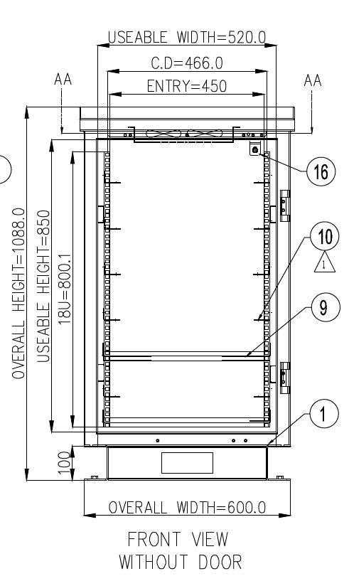

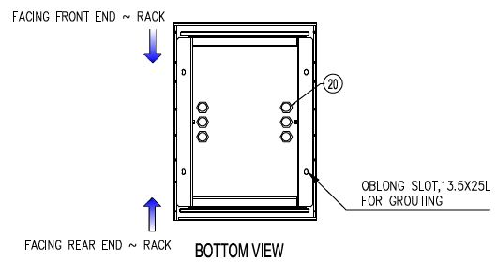

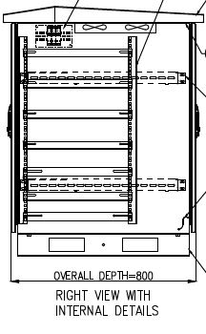



## 1.3 Mechanical Configuration:

The Industrial PC and simulator interface unit is made of HE-30.This is mounted in a 19” rack made of MS, consisting of doors at the front & rear with locks. The KVM (keyboard, video, and mouse) unit is mounted in the rack on top, below which the industrial PC, MIU, 3U size simulator interface unit and the 4U size cable tray are mounted on the slides. Cable tray is for keeping the umbilical cables including AC power input cable. The AC power extension point should be provided on the rear side of the simulator rack. Four 6A, 3-pin AC sockets to be provided on the AC power extension point (one socket for IPC, one for SIU and two for spare). MIU has to be mounted on a tray, with slides for fitment in rack. Mil-std-1553B couplers will be part of the 1553 cables.

## Overall View of Simulator Rack

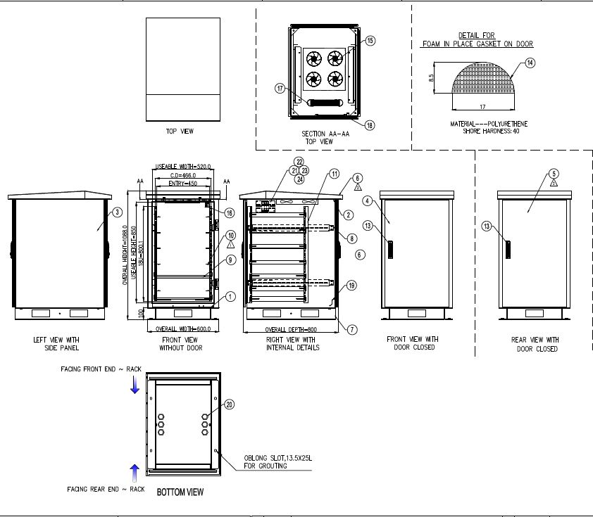

# 2.0 LEVEL II SIMULATOR PC

**2.1 IDENTIFICATION:**

The “Level II simulator” supplied by Datasol to ASL, Hyderabad will be here after identified as given below.

TITLE : HARDWARE DESIGN DOCUMENT for “Level II Simulator”

SYSTEM : LEVEL II SIMULATOR PC

PART NO : DSL-SIMPC



**Fig. 1: Level II Simulator PC**

## 2.2 INTRODUCTION

Level II Simulator PC is basically a MIL qualified system with required connectivity as specified by ASL Hyderabad.

* GIGA bit Ethernets
* Discrete I/O
* USB Ports
* KVM (Keyboard, VGA & Mouse (Touchpad).

The design is built around i7 based processor board (Nupro E42) mounted on a backplane (EBP-6E2) where required peripherals / connectivity will be achieved. The unit has 500GB SATA (HDD), where the application program and the OS reside. The unit performance can be checked with a PC based test jig which will facilitate simulation of 1553 communication and other peripherals. Components used will be Standard connectors & Industrial grade.

Level2 simulator is used to test the total checkout system connectivity and to validate the command‐response protocol.

**Level II simulator PC consists of**

* Simulator rack
* Simulator PC
* Simulator Interface unit
* MIU mounted on a tray
* Cable tray
* Set of interfacing cables

The simulator PC consists of two node 1553 card for communication with embedded computer (MIU‐missile interface unit) and LIU. MIU has got all the digital and analog inputs and outputs that collects umbilical data from checkout system periodically and posts them to Simulator PC. Simulator Interface Unit consists of the signal conditioner, power supply and the external interface connectors.

## 2.3DOCUMENT OVERVIEW

This document describes in detail the scope, design, performance & qualification aspects of the “Level II Simulator”.

The document is organized into the following sections:

Section 1: Scope of the document (including identification of the system).

Section 2: introduction of the “Level II Simulator (including document overview & reference document).

Section 3: Functional block diagram with brief description of “Level II Simulator” design.

Section 4: Technical description of “Level II Simulator” for each module.

Section 5: Connector & wiring details.

**REFERENCE DOCUMENTS:**

The following list of reference may be helpful for you to understand the concept of the custom design.

Specification: Technical Specification as given in the P.O.

**SPECIFICATION REQUIREMENTS:**

The technical specifications as well as the deliverables and Quantity details have been given by the customer also described.

## 2.4 SYSTEM OVERVIEW

“Simulator PC” is a 19” rack mountable system, based on a Single Board Computer (SBC) card. The SBC board houses a 2.2 GHz Intel Core i7 Processor with 4 GB integrated RAM. “Simulator PC “consists of dual node Mil‐Std‐1553B‐PCI card DDC-BU-67110i200R-JL0 in a single chassis.

The Simulator PC is powered 1U form factor 300W AC power supply operating on input range 110 ~ 220VAC. Simulator system, all I/O’s from RIO (Rear input / output) modules are terminated on D38999 / MS3470 circular connectors at the rear plate. It Interface to the MIU & SIU (Test jig) as per configuration. System is also provided with USB, Power, J1, LAN Ports, 1553 cards circular connector & R/W DVD Drive.

## 2.5 SYSTEM CONFIGURATION

“Level II Simulator” consists of the following subsystems /modules.

|  |  |  |  |  |
| --- | --- | --- | --- | --- |
| **S/N** | **ITEM** | **Supplier Reference** | **Part number** | **Qty** |
| 1 | Level II Simulator consists of Rear side having 2 USB Ports, 2 LAN ports, 1 KVM Power circular connector, 1 1553 circular connector with part number D38999-20WB-35S. In front side having DVD re-writable drive, HDD indicator LED, Power LED, Reset Switch, ON/OFF switch & 2 USB ports | Datasol | DSL-SIMPC | 1 |
| 2 | DDC Multifunctional DAQ module, -JL0 Dual node 1553 PCI | DDC | BU-67110i200R | 1 |
| 4 | KVM (Keyboard / Video / Mouse) | Datasol | DSL-SIMKVM | 1 |
| 5 | Simulator interface unit (SIU) | Datasol | DSL-SIU | 1 |
| 6 | Interface Cable Assemblies (Cable tray) | Datasol | DSL-SIMCA | 1 |
| 7 | Simulator Rack | Datasol | DSL-SIMRACK | 1 |

**Table 1: System Configuration.**

## 2.6 HARDWARE SPECIFICATIONS

|  |  |  |
| --- | --- | --- |
| **SL No** | **Features** | **Specifications** |
| **1** | **Simulator PC 6U Chassis -DSL-SIMPC** | * + Form Factor : 6U   + No. of Segments: Single 6U system having 3 PCI, 1X 4PCIe, 1X AGP, 1X PICMG 1.3 backplane.   + Power Supply : 300W Interface 220VAC ±10%   + I/O Interface : I/O backplane with USB, Serial, LAN Ports, & R/W DVD Drive   + LED Indicators : HDD / Power |
| **2** | **CPU Card -Nupro E42** | * + Processor: Intel Core i7 processor @ 3.1 GHz   + RAM : 8GB DDR3 SDRAM   + Storage Memory: on board 32GB SATA SSD   + SATA Hard Disk 500GB.   + Display : 15” LED Panel supports up to 1024 x 768 (XGA)   + KVM (VGA/KB/TP/PW) through one circular cable rooted at rear panel.   + USB: 4 Nos.   + LAN ports: 3 Nos.   + J1 (power for SIU).   + 1553 circular connector(D38999/20‐F‐B‐35S)   + Operating System : RHEL 6.0 |
| **3** | **Back Plane - EBP-6E2** | * + Segment: 1   + Slots: 1 PICMG® CPU, 1 PCI-E x16, 1 PCI-E x4, 3 PCI   + Support ATX power supplies   + Dimension: 140 mm x 327 mm |
| **4** | **Display -IDS-3115** | * + 15" XGA LED backlight panel which provides 20~30% power saving   + -20°C ~ +60°C wide operating temperature support   + Special design of the 5-wire resistive touchscreen   + The all new mechanical design with integrated bracket for easy installation   + Versatile mounting method for rear mount and VESA mount (75 x 75 mm, 100 x 100 mm) |
| **5** | **DAQ Card - 1553B Dual node BU-67110i200R-JL0** | * + Up to 8 Dual Redundant MIL-STD-1553 Channels   + Single-Function: BC/MT or Multi-RT/MT   + Multi-Function: BC + Multi-RT + MT   + 1553 Bus Playback on All Models   + Supports MIL-STD-1553 A/B & MIL-STD-1760   + Transformer Coupled 1553 Interfaces   + BC Disable for RT Only Applications   + Tx Inhibit for MT Only Applications   + 2 External RT Address Inputs   + Test and Simulation Toolkit   + Variable Voltage Output on Front I/O Models   + Digital/Avionics Discrete I/O Trigger Capability   + Real Time Intermessage Event/Data Modification   + Error Injection   + Intermessage Gap & RT Response Time as low as 3.5 μs   + Up to 8 Digital & 16 Avionics Discrete I/O   + IRIG-B Time Code Input / Output   + 48-bit/100ns Time Stamp   + Low Power Dissipation |
| **6** | **Power Supply**  **APS-9130XU** | * + Power (typical): 300W   + AC Voltage Input Range: Universal   + Certifications: UL/cUL /TUV/CCC   + Dimensions: 190 x 100 x 40.5 (mm) |

**Table2: Hardware Specifications.**

## 2.7 SOFTWARE SPECIFICATIONS

* Operating System – RHEL 6.0.
* Source code for all the test software in Linux (RHEL 6.0)

## 2.8 LEVEL II SIMULATOR ARCHITECTURE

Level2 simulator is interfaced to the MIU through launcher junction box and Mil‐Std‐1553 bus. The power to missile sub‐systems from checkout system is available through various umbilical connectors at the junction box. This will be monitored by either digital or analog input of the MIU through signal conditioning at SIB. Level2 simulator communicates with launcher interface unit (LIU) in checkout system through Mil‐Std‐1553 bus. It receives the commands from checkout system through 1553 bus and responds to the same.

The simulator PC is an industrial Computer with 2 node Mil‐std‐1553B card for communication with LIU and MIU.

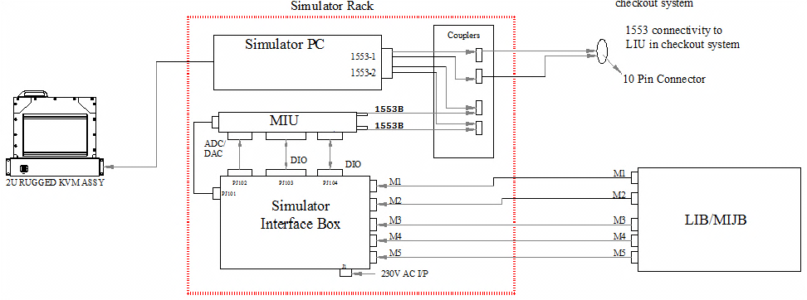

**Fig 1.1: Logical Connectivity of “Level II Simulator PC”**

* **Simulator PC connectors: 1553 B (1553-1 & 1553-2 Dual node).**
* **KVM connectors:**

**LCD Display Interface (KB/Touchpad, VGA, KVM power) - MS3470-W16-26P**

## 2.9 FRONT PANEL VIEW

On the front having the connectors of 2 no’s USB / DVD Drive (R/W) / HDD & Power LED.



**Fig. 2: Level II Simulator PC (Front View)**

## 2.10 REAR PANEL VIEW

Rear side having 2 USB Ports,2 LAN ports, 1 KVM Power circular connector, 1553 circular connector with part number D38999-20WB-35S & J1 connector for power to Simulator PC.



**Fig. 2.1: Level II Simulator PC (Rear View)**

## 2.11 SPECIFICATION OF “SIMULATOR PC” as per PO.

* Simulator PC to be mounted on the 19’ rack with width less than 10”
* Minimum 3 PCI slots for add‐on cards
* Minimum 1 PCI‐express slots for add‐on cards
* In built ball bearing cooling fans with air filter and alarm, with low sound level less than 30dB (to be confirmed with datasheet) or a fan less cooling arrangement.
* Power on/off switch, CPU reset buttons.
* 500 GB SATA.
* 3 USB ports (at least one of USB 2.0) should be provided with termination in front panel.
* Status indicators for power, HDD, Cooling fan if available.
* Input voltage: 180 to 264V AC @50Hz
* VGA resolution up to 1600X1200 or higher.
* The System should be loaded with Red Hat Enterprise Linux 6.0
* 2 independent channels of GbE port with Intel controller. These ports are terminated on the rear panel with standard RJ45 connector.
* Compact flash port with 32GB compact flash.
* Rugged light weight packaging.

## 3.0 Foldable KVM with Display



**Fig 3: Opened KVM with display**

* Membrane keypad.
* Rack mount 85 keys foldablekeyboard.
* Built in pressure activated touch pad fully compatible with Windows & Linux supporting plug and play.
* LCD monitor with resolution up to 1024X768 for 24 bit RGB‐TFT LCD
* 15” active display area.
* CPU to KVM cable length 2m.

**CPU**

* Intel Core i7 Processor @ 2 GHz or higher.
* RAM: 4 GB DDR3
* Built‐in two USB ports. These ports are to be terminated on the front panel.

## 4.0 Mil‐Std‐1553B‐PCI card:

**Mil‐Std‐1553B‐PCI card**

* Make‐DDC
* Part no‐ BU‐67110i200R‐JL0

## DDC-BU-67110i200R-JL0 (Hardware Configuration and Operation)

The BU-67x10F/M/I/T card utilizes the PCI interface, and as such does not require any jumpers or switches to set the Base address or interrupt values. The job of configuration for Plug-and-Play PCI is performed by the operating system. During the initial power on boot process, the system performs an enumeration of the PCI bus and allocates a resource configuration that satisfies the card requirements. The system will save the configuration information in the BU-67x10i PCI configuration space registers. These registers are configured at the factory to contain information that identifies the card type; vendor, required memory sizes, and interrupts resources. When the driver loads it will access the configuration registers and identify how the system has configured the card. After identifying each of the installed cards, the device driver will enumerate each of the channels on the card and create a configuration structure that defines the allocated address and interrupt. This information is directly available to the MIL-STD-1553 AceXtreme Software Development Kit and is necessary for read, write and interrupt operations..



**Fig. 4.0: BU-67x10i Front I/O PCI Card**

# 4.1 FUNCTIONAL DESCRIPTION & HARDWARE ARCHITECTURE

The functional flow chart of the Simulator PC is as shown in Fig. 5. The system is a 6U form factor with necessary switches and monitoring LEDs at the front panel as the name indicates. The rear end of the 1153B card is mounted with 1553 circular connector along with J1, LAN1, LAN2, USB3, USB4 and KVMPWR.

## POWER INTERFACE

* Model: APS-9130XU
* Power type: 300 W
* Maximum DC Output Current: 24 A 20 A 20 A 0.5 A 0.5 A 1.5 A
* Current Type: ATX12V
* AC Voltage Input: 110 ~ 220 VAC (±10%)
* Certifications: UL/CSA/TUV

## 

## COOLING

Simulator PC is fitted with two internal fans inside the chassis. System is cooled by ambient air supplemented by internal fans. Air vents are provided on the front & side plates. The 12V power supply is given to these fans.

## 4.2 SIGNAL FLOW FOR “Level II Simulator”.

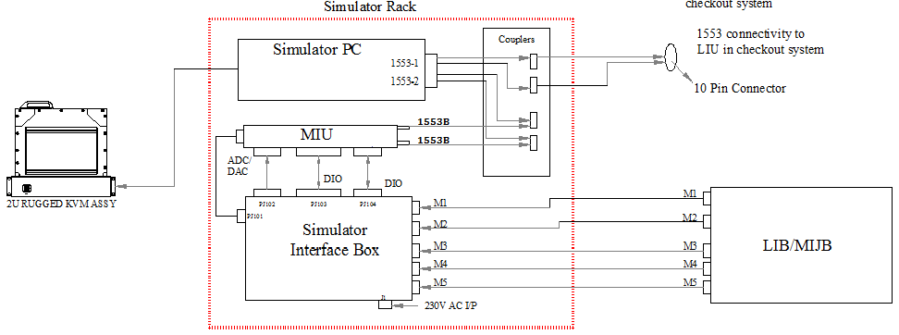Level2 simulator is interfaced to the checkout system through launcher junction box and Mil‐Std‐1553 bus. The power to missile sub‐systems from checkout system is available through various umbilical connectors at the junction box. This will be monitored by either digital input or analog input of the MIU through signal conditioning at SIB.Level2 simulator communicates with launcher interface unit (LIU) in checkout system through Mil‐Std‐1553 bus. It receives the commands from checkout system through 1553 bus and responds to the same.

**Fig 5: Flow Chart of “Level II Simulator”.**

Mil‐Std‐1553B cables are to be integrated with molded inline stub coupler, terminators and respective type of connectors as shown in the schematic below.

* Four integrated cables are supplied for 2 Mil‐std‐1553b nodes for both bus‐A and bus‐B.
* Level2 simulator 1553B node‐1 (level2‐1A&B) will be used for communication with LIU in checkout system and Level2 simulator 1553B node‐2 (level2‐2A&B) will be used for communication with MIU. All the 4 buses are terminated with a single 13 pin connector on the simulator PC.
* For node‐1 connectivity, a dual stub coupler with one end terminator and the other end of the bus extended 10pin connector as LC bus for LIU connectivity is used. The second stub line will be used for monitoring purpose if required. For bus‐B also same connectivity is repeated with LC bus termination on the same 10 pin connector.
* For node‐2 connectivity, a three stub coupler with terminators on both bus ends is used. The second stub connected to MIU‐bus‐A and the third stub line will be used for monitoring purpose if required. For bus‐B also same connectivity is repeated.





**Fig 6: schematic showing Connectivity.**

## 

# 5.0 CPU CARD

The ADLINK NuPRO-E42 is a PICMG 1.3 System Host Board (SHB) supporting the 4th Generation Intel® Core™ i7/i5/i3 and Pentium® processors in LGA1150 package to deliver a scalable high performance platform for a wide array of industrial applications. The NuPRO-E42 supports 22nm process CPUs at up to 3.5 GHz with integrated graphics and memory controllers, Direct Media Interface (DMI) and Flexible Display Interface (FDI) connectivity to the Intel® Q87 Express Chipset. Dual-channel DDR3 memory is supported up to a maximum of 16 GB in two DIMM slots.

These advanced features, coupled with PCI Express® x16 expansion capability, dual PCI Express-based Gigabit Ethernet, SATA 6 Gb/s and USB 3.0 support make the NuPRO-E42 ideal for vision and automation control applications.

## 5.1 CPU CARD FEATURES

Supports Intel® Core™ i7/i5/i3 and Pentium® processors in LGA1155 package

* Integrated Intel® HD Graphics
* PCI Express® x16 expansion capability via backplane
* Dual Gigabit Ethernet
* 6x USB 3.0 ports (2x on rear panel, 4x on SHB)
* 4x USB 2.0 ports on backplane
* 4x SATA 6 Gb/s ports on SHB
* 6x COM ports (including 1x RS-232/422/485)
* Watchdog Timer, Hardware Monitor
* Optional HD audio kit (DB-Audio2 daughter board)
* TPM hardware security chip
* RoHS compliant

## 5.2BACKPLANE specification:

|  |  |
| --- | --- |
| PCI-E X 16 | 1 |
| PCI-E X 4 | 1 |
| PCI TM | 3 |
| PICMG | 1 |
| ATX | YES |
| SEGMENT | 1 |
| DIMENSIONS | 328 X 140 mm |

## 5.3DIGITAL COMMUNICATION CARD

The 1553B with part #: BU-67110i is a PCI card. The BU-67110i Series contains up to eight dual redundant MIL-STD-1553 channels and is a perfect fit for military aerospace applications. The PCI versions offer front panel I/O and include a cable to easily interface to all 1553 channels. The unique I/O mix and high channel count on a single card saves space, power, weight, and cost-making this ideal solution for systems with limited space.

The card includes the AceXtreme MIL-STD-1553 C Software Development Kit (SDK) and drivers to support all modes of operation for Linux, VxWorks and Windows 2000/XP/Vista/7, including source code samples and detailed documentation. A common SDK exists across all operating systems for all cards allowing the programmer protability across different –platforms. The BusTrACEr Graphical User Interface is optionally available and has point and click application source code generation capability to reduce risk and shorten development cycles.

All bus relative configurations, such as base memory and interrupt assignment, are automatically controlled by BIOS software.3U Compact PCI with Rear I/O has following features**.**

## 5.4 1553B CARD FEATURES

* Up to (8) Dual Redundant MIL-STD-1553 Channels.
* Multi – Function: BC/MT or Multi – RT/MT.
* 1553 Bus Playback on all models.
* Supports MIL-STD-1553 A/B & MIL-STD-1760
* Transformer and / or direct coupled.
* BC Disable for RT only applications.
* Tx inhibit for MT only applications.
* 2 External RT address Inputs

## 5.5 1553B CARD BENEFITS

* Rugged PMC Design for Harsh Environments.
* Available in PCI form factors with cable for test environment
* Unique I/O Mix & High Channel Count Reduces: Space, Power, Weight, and Cost.
* Shorten Development Cycle and Reduce Risk with Automated Code Generation
* IRIG-106 Chapter 10 On-board formatting.
* On-Board DMA engine for low CPU-PCI utilization.

## 5.6 SOFTWARE INSTALLAION 1553B card:

The Software Development Kits (SDK) is included on the supplied Software CD. Insert the disc and open the file directory.



MIL-STD-1553 AceXtreme SDK: BU-69092S1

Unzip the file: BU69092S1_X_Y_Z.zip.

Note: X_Y_Z = revision number

For installation from CD: Navigate to the BU-69092S1 folder.

## 5.7 PCI connections 1553B card:

Insert the card and gently press into the corresponding connector. Secure with proper hardware, if required.



Connect the I/O cable to the connector.

Ensure that standard ESD precautions are followed.

## 5.8 HARDWARE INSTALLAION 1553B card:

Using the appropriate installation script, follow the prompts to install the package. The script will guide you through building the drivers, installing the library, and setting up the device for the first time.



MIL-STD-1553 AceXterme SDK: BU-69092S1 Installation script for MIL-STD-1553 aceXInstall.

## 5.9 LOGICAL DEVICE NUMBER ASSIGNMENT 1553B card:

Assign a Logical Device Number to the PCI card in the DDC card manager. The DDC card manager can be launched by typing ***ddccm*** into the console.



You are now ready to use the PCI card with your installed SDK.

# 6.0 ELECTRICAL INTERFACES & CONNECTORS.

The “Simulator PC” as 7 connectors on rear side and 2 connectors on the front. The location of these connectors is as mentioned in fig 1.1 & 1.2.

## SIMULATOR PC REAR PANEL CONNECTORS.

|  |  |  |  |  |
| --- | --- | --- | --- | --- |
| S/N | Connector Description | Connector  Identification | Mounting  Type | Connector Part Number |
| 1 | 1553 | 1553 Dual node card | Fixed-13S | 13S Circular Part No: D38999/20-F-B-35S |
| 2 | AC i/p | AC Power | Fixed‐3P | 3P Circular Part No: MS3470‐W12‐3P |
| 3 | LAN | ETHERNET CONNECTOR | Fixed | RJ45 |
| 4 | USB | USB PORT CONNECTOR (Should be brought in front of the PC) | - | Standard USB Connector |
| 5 | KVM POWER | LCD Display Interface (KB/Mouse, VGA, KVM Power) | Fixed-26S | 26S Circular Part No: MS3470-W-16-26S |

### CONNECTORS MOUNTED ON THE REAR PANEL OF KVM

|  |  |  |  |  |
| --- | --- | --- | --- | --- |
| S/N | Connector Identification | Connector  Description | Mounting  Type | Connector Part Number |
| 1 | KVM I/P | LCD Display Interface (KB/Mouse, VGA, KVM Power) | Fixed‐26P | 26P Part No: MS3470‐W16‐26P |

### 6.3 WIRING DETAILS FROM MOTHER BOARD TO CONNECTORS AT CHASSIS END

|  |  |  |
| --- | --- | --- |
| **VGA** | | |
| Pin # | Signal details | Circular connector pin no’s MS3470-W16-26S |
| 1 | Red | 1 |
| 2 | Green | 2 |
| 3 | Blue | 3 |
| 4 | NC | - |
| 5 | GND | 4 |
| 6 | GND | - |
| 7 | GND | - |
| 8 | GND | 5 |
| 9 | +5 V | - |
| 10 | GND | 6 |
| 11 | NC | - |
| 12 | DDC DATA | 7 |
| 13 | HSYNC | 8 |
| 14 | VSYNC | 9 |
| 15 | DDC CLK | 10 |

|  |  |  |
| --- | --- | --- |
| **KEYBOARD / MOUSE (TP)** | | |
| KEY BOARD Pin # | Signal details | Circular connector pin no’s MS3470-W16-26S |
| 1 | K/B data | 12 |
| 3 | GND | 13 |
| 4 | VCC | 14 |
| 5 | K/B clock | 15 |
| MOUSE Pin # | Signal details | Circular connector pin no’s MS3470-W16-26S |
| 1 | Mouse data | 16 |
| 3 | GND | 17 |
| 4 | VCC | 18 |
| 5 | Mouse clock | 19 |

|  |  |  |
| --- | --- | --- |
| **LAN** | | |
| Pin # | COLOUR CODE | Standard Connector RJ 45 male connector |
| 1 | White / Orange | 1 |
| 2 | Orange | 2 |
| 3 | White / Green | 3 |
| 4 | Blue | 4 |
| 5 | White / Blue | 5 |
| 6 | Green | 6 |
| 7 | White / Brown | 7 |
| 8 | Brown | 8 |

|  |  |  |
| --- | --- | --- |
| **USB 3.0** | | |
| Pin # | Signal | Standard male connector |
| 1 | VCC | 1 |
| 2 | Data - | 2 |
| 3 | Data + | 3 |
| 4 | GND | 4 |

|  |  |  |
| --- | --- | --- |
| **USB 2.0** | | |
| Pin # | Signal | Standard male connector |
| 1 | VCC | 1 |
| 2 | Data - | 2 |
| 3 | Data + | 3 |
| 4 | GND | 4 |

|  |  |  |
| --- | --- | --- |
| **JI (PWR for SIU)** | | |
| Circular connector pin no’s MS3470-W12-3PN | Signal | 3 Pin 5Amps Socket |
| 1 | Line | Line |
| 2 | Neutral | Neutral |
| 3 | GND | GND |

|  |  |  |
| --- | --- | --- |
| **1553B CABLE DETAILS** | | |
| **Source connector D38999 20-WB-35SN** | **PIN No** | **Signal** |
| **D38999 20-WB-35SN** | **1** | **BUS1 A(H)** |
| **2** | **BUS1 A(L)** |
| **3** | **BUS1 A(Shield)** |
| **9** | **BUS1 B(H)** |
| **10** | **BUS1 B(L)** |
| **11** | **BUS1 B(Shield)** |
| **4** | **BUS 2 A(H)** |
| **5** | **BUS2 A(L)** |
| **12** | **BUS2 A(Shield)** |
| **7** | **BUS2 B(H)** |
| **8** | **BUS2 B(L)** |
| **13** | **BUS2 B(Shield)** |

## INTERCONNECTIONS FOR IO CARDS TO REAR PANEL CIRCULAR CONNECTORS

The circular connectors are rooted through the on-board connectors, these connectors are of MIL Standard, each connectors having matting as part numbers mentioned. All the connectors are labelled on the chassis.

# MECHANICAL DESIGN

The Simulator PC and simulator interface unit is made of HE‐30. This is mounted in a 19” rack made of MS, consisting of doors at the front and rear with locks. The KVM (keyboard, video and mouse) unit is mounted in the rack on top, below which the Simulator PC, MIU, 3U size simulator interface unit and the 4U size cable tray are mounted on the slides. Cable tray is for keeping the umbilical cables including AC power input cable. The AC power extension point should be provided on the rear side of the simulator rack. Four 6A, 3‐ pin AC sockets to be provided on the AC Power extension point (one socket for Simulator PC, one for SIU and two for spare). MIU has to be mounted on a tray, with slides for fitment in rack. Mil‐Std‐1553B couplers will be part of the 1553 cables.



**Fig 7: Simulator Rack**

|  |  |
| --- | --- |
| Measures | Dimensions(max) |
| Height | 6U |
| Width(mm) | 19” inch rack mountable |

## 7.2 MECHANICALMODEL



**Fig 8: Mechanical Model (Simulator PC)**

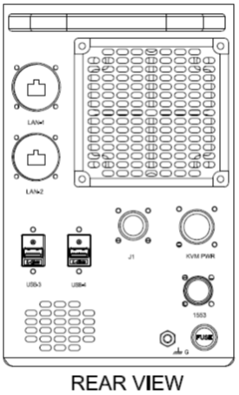



**Fig 8.1: Rear Views with Interfaces**



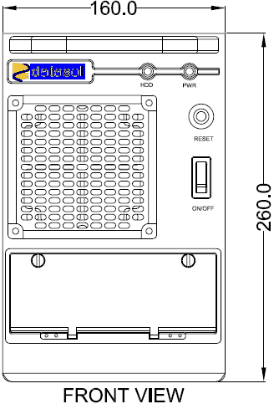

**Fig 8.2: Front Views with Interfaces**

## 7.3 SIMULATOR PC MECHANICAL DRAWING INDEX

Refer Mechanical QAP document (MQAP), in which the Mechanical Drawing Index & Mechanical Drawings are detailed.

## 7.4 MECHANICAL LAYOUT



**Fig 8.3: Explode View (Simulator PC).**



**Fig 8.4: Front View (Simulator PC).**



**Fig 8.5: Rear View (Simulator PC).**

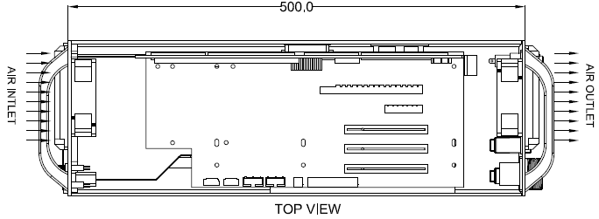

**Fig 8.6: Top View (Simulator PC).**

## 7.5 EMI / EMC TESTS SPECIFICATIONS

|  |  |  |  |
| --- | --- | --- | --- |
| ***DETAILED EMI / EMC TEST SPECIFICATION AS PER 461E*** | | | |
| ***S N*** | ***TEST*** | ***TEST DESCRIPTION*** | ***Remarks*** |
| 1 | CS 101 | Conducted Susceptibility power leads, 30Hz to 150KHz. | PREET/ INSET /POET |
| 2 | CS114 | Conducted Susceptibility, Bulk Cable Injection, 10KHz to 200 MHz | PREET/ INSET /POET |
| 3 | CS115 | Conducted Susceptibility, Bulk Cable Injection, Impulse Excitation. | PREET/ INSET /POET |
| 4 | CS 116 | Conducted Susceptibility, damped sinusoidal transients 10kHz to 100MHz | PREET/ INSET /POET |
| 5 | CS 103 | Radiated Susceptibility Electric Field, 2MHz to 18GHz | PREET/ INSET /POET |
| 6 | HESD | Human Electrostatic Discharge | PREET/ INSET /POET |
| 7 | RE102 | Radiated Emissions, electric field, 2MHz to 18 GHz | PREET/ INSET /POET |
| 8 | CE 102 | Conducted Emissions, power leads, 10KHz to 10MHz | PREET/ INSET /POET |
| 9 |  | Random Vibration (Along all the three axes) | PREET & POET |
| 10 |  | Temperature Cycling | PREET at ambient INSET to be done 2 times every cycle. 1st before switching OFF (at the end of 550C condition; during the last 15 minutes of dwelling period) and 2nd after switching ON (at the end of 200C condition; during the last 15 minutes of dwelling period). POET at ambient. |
| 11 |  | Random Vibration (Along all the three axes) | PREET & POET |
| 12 |  | Damp Heat | PREET at ambient INSET at 7 1/2 Hr POET at ambient. |
| 13 |  | EMI / EMC | Find the above ESS test column |

**APPENDIX-A**



**APPENDIX-B**

**List of Deliverables for A3 batch:**

|  |  |  |
| --- | --- | --- |
| **SL No** | **Description** | **Quantity** |
| 1 | Level 2 Simulator as per the attached technical specifications (PC + SIU + Rack+Cable tray + Mounting tray) | 5 Nos |
| 2 | SIU to LJB cables for type 1 configuration | 5 Sets |
| 3 | REDHAT Enterprise Linux 6.0 Licensed version | 1 Set |
| 4 | Driver Software & Test software for 1553 card | 1 Set |
| 5 | Simulator PC test software | 1 |
| 6 | USB based external DVD drive | 1 |

**Spares to be supplied as listed below:**

The following items used in simulator are to be suppled as spares. The make and part no of the spares should be the same as what has been used in the simulator.

|  |  |  |
| --- | --- | --- |
| **SL No** | **Item** | **Quantity** |
| 1 | DC-DC convertor | 10 nos |
| 2 | Relays 1A DPDT/28 Coil supply | 10 nos |

**List of Deliverables for A4 batch:**

|  |  |  |
| --- | --- | --- |
| **SL No** | **Description** | **Quantity** |
| 1 | Level 2 Simulator as per the attached technical specifications (PC + SIU + Rack+Cable tray + Mounting tray) | 6 Nos |
| 2 | Simulator Test Jig with interfacing cables and test software | 1 Set |
| 3 | Simulator Interfacing Cables | 6 Sets |
| 4 | REDHAT Enterprise Linux 6.0 Licensed version | 1 Set |
| 5 | SIU to LJB cables type 2 configuration | 6 Set |

**List of Deliverables for A5 batch:**

|  |  |  |
| --- | --- | --- |
| **SL No** | **Description** | **Quantity** |
| 1 | Level 2 Simulator as per the attached technical specifications (PC + SIU + Rack+Cable tray + Mounting tray) | 6 Nos |
| 2 | Simulator Test Jig with interfacing cables and test software | 1 Set |
| 3 | Simulator Interfacing Cables | 6 Sets |
| 4 | REDHAT Enterprise Linux 6.0 Licensed version | 1 Set |
| 5 | SIU to LJB cables type 3 configuration | 6 Set |

**APPENDIX-C**

**LIST OF DELIVERABLE FOR OVERALL 17 NO’s SYSTEMS with SPARES**

|  |  |  |
| --- | --- | --- |
| **SL No** | **Item Description** | **Quantity** |
| 1 | 19” Rack with front ad rear door, cable tray & mounting tray, AC power extension point. | 17 Sets |
| **Model No: DSL-SIMPC**  19” Half Rack mount 5U level 2 simulator PC with DDC make BU-67110i200R-JL0: PCI dual node 1553B card and I/O’s are terminated on MIL-Series D38999 connector. |
| Model No: DSL-KVM15  19” rackmount 2U, 15” Display with keyboard and touchpad with mating cables. |
| **Model No: DSL-SIU**  19” rack mount 4U simulator interface unit. |
| MIL-STD-1553B Data Bus Network.  Make – CompuPower |
| 2 | Simulator Interfacing Cables | 17 Sets |
| 3 | SIU to LJB cables for type –1 configuration | 05 Sets |
| 4 | SIU to LJB cables for type –2 configuration | 06 Sets |
| 5 | SIU to LJB cables for type –3 configuration | 06 Sets |
| 6 | **Model No: DSL-Testjig**  Simulator Test Jig with interfacing cables with simulator PC test software | 02 Sets |
| 7 | REDHAT Enterprise Linux 6.0 or above with media and 1 year support | 03 Sets |
| 8 | Driver Software & Test Software for 1553B Card | 01 Set |
| 9 | Simulator PC test software | 01 No |
| 10 | External USB based DVD drive | 01 No |
| **SPARES** | | |
| 11 | DC-DC Converter Murata UMR-5/2000/D24E-C 28V/5V-2A | 10 Nos |
| 12 | Relay 1A DPDT/28 Coil supply | 10 Nos |

**APPENDIX-D**

**1553 CABLE ASSEMBLY**



**APPENDIX-E**

**1553 CABLE ASSEMBLY**



**APPENDIX-F**

**MECHANICAL RACK PROPOSAL DRAWING**



8. SIMULATOR INTERFACE UNIT : 6nos.

8.1 MECHANICAL CONSTRUCTION:

It is made up of aluminium alloy of HE30 Grade. For mounting the MIL-circular connectors on the front & rear panel will be milled for the foot print of the connectors, and it will be mounted on the front of the panel. The mounting of the Terminal Blocks weleded welded on the bottom/side plate. The mounting provision for EMI – gaskets will be made as per requirement of the gasket. The dimensions of the unit will be:

HEIGHT: 133mm.

DEPTH: 350mm

WIDTH: 482mm









8.2 SYSTEM OVERVIEW:

This system contains the circuits for conditioning the signals from the checkout system to meet the MIU input specifications. It interfaces umbilical signals from checkout system to the MIU. MIU has got the resources such as digital input, digital output, ADC and DACs .The following circuits are to be incorporated in PCBs inside SIU to ensure that umbilical signals meet the MIU resource specifications.

Current limiting resistor cum opto isolator circuit

Voltage level shifting Circuit

Relay circuit which will be operated by MIU DOPs

Power supplies circuit.

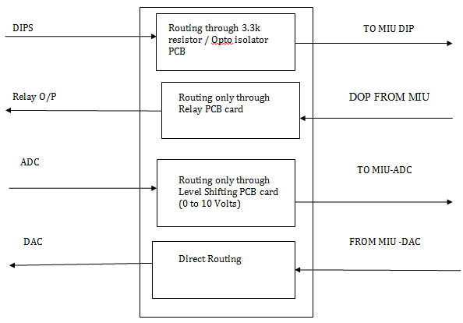

8.3 CURRENT LIMITING RESISTOR and OPTO ISOLATOR CIRCUIT:

These cards specially developed for this application. Taken care while design for the Industrial standards. It read 35V input, to limit the current for input voltage of 35V, we are using current limiting resistor of 3.3k/0.25W is provided at the input of each channel, Thus for each channel, one 3.3k resistor is used at SIU. For 86 channels, all 86 resistors are mounted on a PCB terminated with D-sub connectors for input and output in simulator interface Unit.



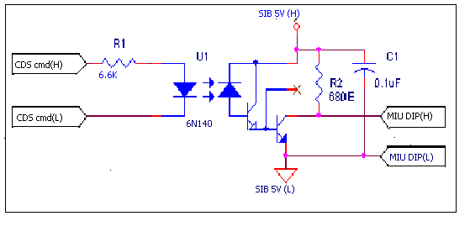

Fig 8.6: opto isolator circuit

There are few umbilical signals namely CDS1 and CDS2, who’s output through low break in checkout system.

8.4 VOLTAGE LEVEL SHIFTING CIRCUIT:

The voltage divider network to bring down the voltage 35V to 10V or less than 10V ,the following divider network will used where ,the output voltage will be 7.4V for input of 35V.The Zener provides the protection in case of any resistor failure.

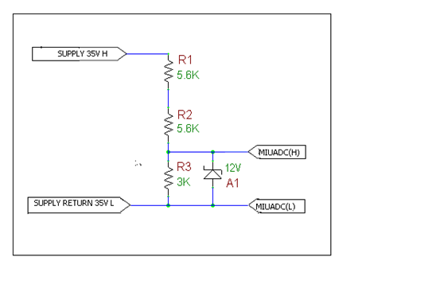

Fig 8.7: level shifting circuit

For all the 48 channels of ADC, the input has to pass through the above circuit and then to MIU ADC channels. All channels of voltage divider network are to be populated in a PCB with input and outputs terminated in D-sub connectors in the Simulator Interface Unit.

8.5 RELAY CIRCUIT TO BE OPERATED BY MIU DOP:

The relays are used for switching the relay coil supply of heater lines in the checkout system as shown below and to switch simulated battery supply to discharge voltage Monitoring lines will be operated by digital output from MIU



Fig 8.8: Relaycircuit

8.6 BATTERY SIMULATION:

The battery simulation circuit have a power source, a current limiting resistor to limit the current in case discharge load is connected and a relay to switch on or off the stimulated battery based on the command from checkout system. Digital output has to drive the relay for which source of 28V (coil supply for relays) is required and will be provide by MIU

Battery discharge lines of checkout system can be cleared by Battery simulation with 28V/5A AC-DC converter. This 28V/5A AC-DC converter simulates either 2 batteries whose total load current will be 33.42A or a single battery whose load current will be 4.5A.Since this load current cannot be supplied by simulated battery (28V/5A AC-DC converter), a CURRENT LIMITNG RESISTOR OF VALUE 10K/0.25w is put on the umbilical line in SIU that takes the simulated battery line into the discharge load. Battery high line requires a break which is simulated by a 1A SPDT NL relay AT SIMULATOR JUNCTION BOX.

Two relays will be used for routing AC-DC output lines to discharge load resistors while simulating 2 batteries and a single relay will be used while simulating single battery. These relays are operated by MIU DOP based on command from checkout system.



8.7 POWER SUPPLY CIRCUIT:

Two AC-DC Converters 28V/5A output are required, one to provide input power to MIU and DC-DC convertor and another one to simulate battery. DC-DC converter output provides Vcc for opt isolator in the SIU. Both power supply modules should be mounted inside the simulator interface unit. Toggle switch is providing for AC input and DC-DC converter output. In the simulator interface unit, EMI filter be used in the power input line to the Ac-dc converter. Shielded twisted pair cables have to be used for wiring of the power lines from the connector tom the input of DC-DC converter.

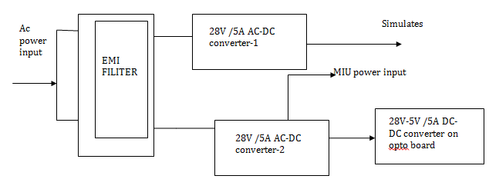

8.8 POWER SUPPLY:

Power supply will be mounted inside the simulator junction box as shown in the and the termination of the supply will be through terminal blocks mounted on din-rail and distributed to the opto boards and relay contacts.

Input: 230VAC

Outputs: SIM 28V: 28V @5Amps,

PC 5V: 5V @5Amps

SIM 5V: 5V @5Amps.

The following models of MEANWELL will be used in the system

POWER SUPPLY (AC-DC):

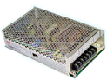

RSP-150-27: 28V @ 5Amps (SIM 28V).

MODEL: S-150-27

SPECIFICATION

DC OUTPUT VOLTAGE: 28V

OUTPUT V. TOLERANCE: ±1%

OUTPUT RATED CURRENT: 5.6A

OUTPUT CURRENT RANGE: 0-5.6A

RIPPLE & NOISE: 240mV (p-p)

Two AC-DC converters of 28V/5A output required, one to provide input power to MIU and dc-dc convertor and another one to simulate battery. dc –dc converter output provides vcc

DC-DC Converter specs:

Make: Murata

Part no: UWR-5/2000-D24E-C

Input voltage: 18-36V

Output: 5V/2A-10W

Efficiency>80%

8.9 ELECTRICAL CONFIGURATION:

All the cables used for wiring will be of LCSO approved PTFE/TEFLON insulated silver-plated copper wire. The following cables used for wiring.

Teflon cables: 22/19/32E for signal wiring and 20/19/32E, for power wiring. The type of cable used on each connector is mentioned in the following table.

|  |  |  |  |  |  |  |
| --- | --- | --- | --- | --- | --- | --- |
| SL NO. | CONNECTOR REF | CONNECTOR PART NO | NO. OF WIRES | AWG | PINS | UNUSED PINS |
| 1 | J1 | MS3470-W12-3PN | 3 | 20AWG | A,B,C |  |
| 2 | J101 | MS3470-W12-10SN | 4 | 20AWG | A,B,C,D | E,F,G,H,J,K |
| 3 | M1 | MS3470-W24-61SN | 60 | 20AWG | A to Z,a to Z,AA to NN | PP |
| 4 | M2 | MS3470-W24-61PN | 60 | 20AWG | A to Z,a to Z,AA to NN | PP |
| 5 | M3 | MS3470-W22-55PN | 54 | 20AWG | A to Z,a to Z,AA to GG | HH |
| 6 | M4 | D38999-20WG 35PN | 78 | 22AWG | 1 to 78 | 79 |
| 7 | M5 | D38999-20WH-35PN | 32 | 22AWG | 1to22,25 to 34 | 23,24,35 to 100 |
| 8 | DOP-J103 | D38999 20WF35PN | 66 | 22AWG | 2to18,61 to 66 | 19 to 60 |
| 9 | DIP-J104 | D38999 20WJ 35PN | 94 | 22AWG | 1 to 78,81 TO 88,95 to102 | 99,100,103 to 128 |
| 10 | DAC/ADC-J102 | D38999-20WJ-35SN | 57 | 22AWG | 1 to 57 | 58 to 128 |

8.10 WIRING DIGARAM:

8.10.1 LEVEL SHIFTER CIRCUIT:



















8.10.2 RESISTOR BOARD CIRCUIT:









8.10.3 OPTO CIRCUIT BOARD:





8.10.4 RELAY CIRCUIT BOARD:









8.10.5 CMS LINES:



8.11 BILL OF MATERIALS:

|  |  |  |  |  |  |
| --- | --- | --- | --- | --- | --- |
| SL.  NO. | PART NUMBER | MAKE | GRADE | QTY PER SYSTEM | DESCRPTION |
| 1 | MS3470 W12-3PN | DEUTSCH/SOURIAU | MIL-STD | 1 |  |
| 2 | MS3470 W12-10SN | DEUTSCH/SOURIAU | MIL-STD | 1 |  |
| 3 | MS3470 W24-61SN | DEUTSCH/SOURIAU | MIL-STD | 1 |  |
| 4 | MS3470 W24-61PN | DEUTSCH/SOURIAU | MIL-STD | 1 |  |
| 5 | MS3470 W22-55PN | DEUTSCH/SOURIAU | MIL-STD | 1 |  |
| 6 | D38999 20WG 35PN | DEUTSCH/SOURIAU | MIL-STD | 1 |  |
| 7 | D38999 20WH-35PN | DEUTSCH/SOURIAU | MIL-STD | 1 |  |
| 8 | D38999 20WF 35PN | DEUTSCH/SOURIAU | MIL-STD | 1 |  |
| 9 | D38999 20WJ 35PN | DEUTSCH/SOURIAU | MIL-STD | 1 |  |
| 10 | D38999-20WJ-35SN | DEUTSCH/SOURIAU | MIL-STD | 1 |  |
| 11 | CURRENT LIMITING RESISTOR PCB | DATASOL | MIL-STD | 1 |  |
| 12 | LEVEL SHIFTER PCB | DATASOL | MIL-STD | 2 |  |
| 13 | RELAY PCB | DATASOL | MIL-STD | 2 |  |
| 14 | OPTO PCB | DATASOL | MIL-STD | 1 |  |
| 18 | AC-DC converter(RSP-150-27) | MEANWELL | INDUSTRIAL | 1 |  |
| 19 | EMI FILTER | EMIS | INDUSTRIAL | 1 |  |
| 20 | HEAT SHRINK SLEEVE |  | INDUSTRIAL |  |  |
| 21 | 2.5mm Ferule | WOER | INDUSTRIAL |  |  |
| 22 | LC134 | JAISREE | INDUSTRIAL |  |  |
| 23 | 261-341 | WAGO | INDUSTRIAL | 54 | 4WAY TB’S |
| 24 | 261-361 | WAGO | INDUSTRIAL | 6 | END PLATES |
| 25 | 210-154 |  | INDUSTRIAL | 3 | ALU RAIL |
| 26 | 209-122 | WAGO | INDUSTRIAL | 6 | STOPPER ON RAIL ENS |

8.11.1 BILL OF MATERIAL OPTO BOARD:

|  |  |  |  |  |  |
| --- | --- | --- | --- | --- | --- |
| SL.NO. | PART | MAKE | GRADE | QTY PER SYSTEM | DESCRPTION |
| 1 | 6N140 / 883B | AVAGO | MIL-STD | 8 |  |
| 2. | 6.6K/0.25W | ACE RESISTORS | INDUSTRIAL | 16 |  |
| 3. | DC-DC convertor UWR-5/200—D24E-C | MURATA | INDUSTRIAL | 1 |  |
| 4. | D-TYPE-37F | DEUTSCH/AMPHENOL/POSITRONICS | INDUSTRIAL | 2 |  |
| 5. | D-TYPE-37M | DEUTSCH/AMPHENOL/POSITRONICS | INDUSTRIAL | 2 |  |

8.11.2 BILL OF MATERIAL CURRENT LIMITING RESISTOR BOARD:

|  |  |  |  |  |  |
| --- | --- | --- | --- | --- | --- |
| SL.  NO. | PART | MAKE | GRADE | QTY PER SYSTEM | DESCRPTION |
| 1. | 3.3K/0.25W | ACE RESISTORS | INDUSTRIAL | 78 |  |
| 2. | 10K/0.25W | ACE RESISTORS | INDUSTRIAL | 1 |  |
| 3. | D-TYPE-44F | DEUTSCH/AMPHENOL/POSITRONICS | INDUSTRIAL | 2 |  |
| 4. | D-TYPE-44M | DEUTSCH/AMPHENOL/POSITRONICS | INDUSTRIAL | 2 |  |

8.11.3 BILL OF MATERIAL CURRENT LEVEL SHIFTER BOARD:

|  |  |  |  |  |  |
| --- | --- | --- | --- | --- | --- |
| SL.  NO. | PART | MAKE | GRADE | QTY PER SYSTEM | DESCRPTION |
| 1 | 5.6K/0.25W | ACE RESISTORS | INDUSTRIAL | 96 |  |
| 2. | 3K/0.25W | ACE RESISTORS | INDUSTRIAL | 48 |  |
| 3. | 1N963B | MICROSEMI/FAIRCHILD | INDUSTRIAL | 48 |  |
| 4. | D-TYPE-50F | DEUTSCH/AMPHENOL/POSITRONICS | INDUSTRIAL | 2 |  |
| 5. | D-TYPE-50M | DEUTSCH/AMPHENOL/POSITRONICS | INDUSTRIAL | 2 |  |

8.11.4 BILL OF MATERIAL RELAY BOARD:

|  |  |  |  |  |  |
| --- | --- | --- | --- | --- | --- |
| SL.  NO. | PART | MAKE | GRADE | QTY PER SYSTEM | DESCRPTION |
| 1 | 1K/0.25W | ACE RESISTORS | INDUSTRIAL | 19 |  |
| 2. | 1A DPDT/28V COIL SUPPLY | OMRON | INDUSTRIAL | 19 |  |
| 3 | D-TYPE-50F | DEUTSCH/AMPHENOL/POSITRONICS | INDUSTRIAL | 1 |  |
| 4 | D-TYPE-50M | DEUTSCH/AMPHENOL/POSITRONICS | INDUSTRIAL | 1 |  |
| 5 | D-TYPE-25F | DEUTSCH/AMPHENOL/POSITRONICS | INDUSTRIAL | 1 |  |
| 6 | D-TYPE-25M | DEUTSCH/AMPHENOL/POSITRONICS | INDUSTRIAL | 1 |  |

8.12 CABLE LOOMS: (6 set)

8.12.1ELECTRICAL CONFIGURATION:

8.12.2 SIU TO LJB INTERFACE CABLES:

|  |  |  |  |  |  |  |
| --- | --- | --- | --- | --- | --- | --- |
| SL NO. | CONNECTOR REF | CONNECTOR PART NO | NO. OF WIRES | AWG | PINS | UNUSED PINS |
| 1 | U1 | MS3475-W24-61SN | 41 | 20AWG | A,B,C,F,G,K,,P,R,U,V,Y to CC,PP | D,E,H,J,M,N,S,T,W,X,a,b, ,DD,GG,HH,JJ,KK,LL,MM,NN |
| 2 | U2 | MS3475-W24-61PN | 51 | 20AWG | A to T,W to EE,PP | u,v,FF,GG,HH,JJ,KK,LL,MM,NN |
| 3 | U3 | MS3475-W24-55SN | 38 | 22AWG | A to V,a to f,i to r,HH | W,g,h,s,t,u,v,x,y,z,AA to GG |
| 4 | M1 | MS3475-W24-61PN | 35 | 22AWG | E To H,P TO a ,c to q, DD to LL | A to D,J to P,b,r to CC,MM to PP |
| 5 | M2 | MS3475-W24-61SN | 60 | 22AWG | A to NN | pp |
| 6 | M3 | MS3475-W22-55SN | 35 | 22AWG | A to U,W to g, r to t,z to BB | V,h to q,u to y,CC to HH |

8.12.3 MIU TO SIU INTERFACE CABLES:

|  |  |  |  |  |  |  |
| --- | --- | --- | --- | --- | --- | --- |
| SL NO. | CONNECTO REF | CONNECTOR PART NO | NO. OF WIRES | AWG | PINS | UNUSED PINS |
| 1 | P102 | D38999-26WJ-35SN | 71 | 22AWG | 1 to 4,8 to 15,29 to 32,34 to39,41,43,46,52 to 65,68 to 74 ,76,79 to 82,85,86,87,90 to 99,101 to 105,112,113 | 5,6,7,16 to 28,33,40 ,42,44,45,47 to 51,66,67,75,77,78,83,84,88,89,100,106 to111,114 to 128 |
| 2 | P103 | D38999-26WE-35SN | 38 | 22AWG | 1 to 14,16 to 25,29 to39,42,43,44 | 15,26,27,28,40,41,45 to 55 |
| 3 | P104 | D38999-26WE-35PN | 14 | 22AWG | 29 to 39,42 to 44 | 1 to 28,40,41,45 to 55 |
| 4 | P105 | D38999-26WJ-35PN | 99 | 22AWG | 1 to 20,22 to 51,55 to 61,64 to 74,76 to104,107,108 | 21,52,53,54, 62,63,75,106,105,109 to128 |
| 5 | P108 | D38999-26WE-35PN | 8 | 22AWG | 22 to30, | 1 to 21,31 to 55 |
| 6 | P101 | MS3470-W12-10S | 4 | 20AWG | A to D | E to K |
| 7 | PJ102 | D38999-26WJ-35PN | 69 | 22AWG | 1 to 57,61 to 72 | 58,59,60,73 to 128 |
| 8 | PJ104 | D38999-26WJ-35SN | 96 | 22AWG | 1 to 88,95 to 102 | 89 to 94, 103 to 128 |
| 9 | PJ103 | D38999-26WF-35SN | 66 | 22AWG | 1 to 46,51 to 64,101 to 106 | 47 to 50,65 to 100,107 to 128 |
| 10 | PJO1 | MS3475-W12-10P | 4 | 20AWG | A to D | E to K |

8.13CABLE LOOMS:SIU TO LJB:

8.13.1 SIU TO LJB INTERFACING CABLE













8.13. MIU TO SIU CABLE LOOMS:





















8.14. BILL OF MATERIALS:

8.14.1 MIU TO SIU LOOMS:

|  |  |  |  |  |  |
| --- | --- | --- | --- | --- | --- |
| S.NO | PART NUMBER | MAKE | GRADE | QTY PER SYSTEM | DESCRPTION |
| 1 | D38999-26WJ-35SN | DEUTSCH/SOURIAU | Mil-STD | 2 |  |
| 2 | D38999-26WE-35PN | DEUTSCH/SOURIAU | Mil-STD | 4 |  |
| 3 | D38999-26WJ-35PN | DEUTSCH/SOURIAU | Mil-STD | 3 |  |
| 4 | D38999-26WE-35SN | DEUTSCH/SOURIAU | Mil-STD | 2 |  |
| 5 | D38999-26WF-35SN | DEUTSCH/SOURIAU | Mil-STD | 1 |  |
| 6 | MS3475 -W12-10S | DEUTSCH/SOURIAU | Mil-STD | 1 |  |
| 7 | MS3475 -W12 -10P | DEUTSCH/SOURIAU | Mil-STD | 1 |  |
| 8 | MS3475 -W12- 3S | DEUTSCH/SOURIAU | Mil-STD | 1 |  |

8.14.2 SIU TO LJB LOOMS:

|  |  |  |  |  |  |
| --- | --- | --- | --- | --- | --- |
| S.NO | CONNECTOR PART NUMBER | MAKE | GRADE | QTY PER SYSTEM | DESCRPTION |
| 1 | MS3475-W24-61PN | DEUTSCH/SOURIAU | Mil-STD | 2 |  |
| 2 | MS3475-W24-61SN | DEUTSCH/SOURIAU | Mil-STD | 2 |  |
| 3 | MS3475-W22-55SN | DEUTSCH/SOURIAU | Mil-STD | 2 |  |
| 4 | MS3475-W22-55PN | DEUTSCH/SOURIAU | Mil-STD | 1 |  |
| 5 | MS3475-W14-19PN | DEUTSCH/SOURIAU | Mil-STD | 1 |  |
| 6 | D38999-26WH-35SN | DEUTSCH/SOURIAU | Mil-STD | 1 |  |
| 7 | D38999-26WH-35GN | DEUTSCH/SOURIAU | Mil-STD | 1 |  |
| 8 | MS3475-W20-41PN | DEUTSCH/SOURIAU | Mil-STD | 1 |  |



OPTO BOARD LAYOUT:





RESISTOR BOARD LAYOUT:





RELAY PCB BOARD LAYOUT:





LEVEL SHIFTER LAYOUT:

